**University of Petroleum and Energy Studies**

School of Computer Science

Department of Cybernetics



**Graphics & Animation Tools**

**LAB FILE**

**(Session: 2020-2021)**

Course: B. Tech with Specialization in Open Source and Open Standards

Batch: 2017-2021

Semester: VIIth

**Submitted By: -**

Bhanu Singla

Roll No: R100217018

SAP ID: 500062436

**Submitted To: -**

Dr. Durgansh Sharma Assistant Professor

Department of Cybernetics

Task 1- Create any Mountain Range with Snowfall over it using GIMP

1. Open GIMP, create a new layer with white background.

2. Open an image of the mountain as layers in GIMP and create a new transparent layer to draw boundaries.

3. Use the ‘Paths tool’ over the image and start selecting boundaries and layout of the image.

4. After selection of layout/ boundaries, go to ‘Select’, choose the ‘From Path’ option and your path will be selected.

5. After the path is selected click on ‘bucket fill tool’ from the toolbar and colour the mountain with your desired colour.

6. Repeat step 3,4,5 for creating the grass and sky of the scene.

7. Structure of the mountain scene is complete.

8. Use your creativity to style the snow cap and when you feel it’s good, then place it at the top of the mountain range.

9. For adding snowfall effect, add a new layer of black colour over all the layers and set the photo effect from normal to screen.

10. Go to Filters -> Noise -> RGB Noise and then press ‘OK’, this will add some noise to the image and make it translucent.

11.Again, Go to Filters -> Blur -> Pixelated and then press ‘OK’, this will make the noise effect pixelated. 12.Then, Go to Filters -> Blur -> Motion Blur and then press ‘OK’.

13.After completing the above steps, Go to Colors -> Levels and adjust the white and black input levels till you find a pixelated snow effect over your image.

14.Remove the extra layers.

**Output**

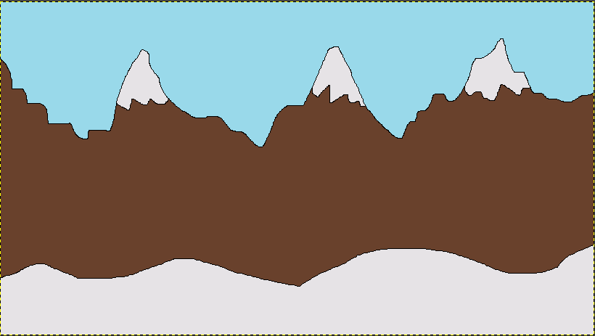

Task 2: Create any City or Skyscraper using Blender

1. Start with the default cube

2. Now enter edit mode(TAB) and loop cut (CTRL + R) it about the center, like so:

3. Select all the faces of the top half and separate them (P->Selection)

4. In object mode move the newly separated top portion up along the Z axis (G + Z + mouse)

5. Select the bottom box, make a copy (SHIFT + D), then move it up along the Z axis.

6. Select the middle piece, switch to edit mode, select the bottom face and delete it (x –> faces), like so:

7. This face is going to represent the various floors of your building. Keep the top and bottom edges the same size as the top/bottom box and start carving it up to match your floor. I generally start by doing a pair of loop cuts along the entire length, like so:

8. This can be accomplished by doing a loop cut (Ctrl + R), then before clicking to commit, scroll button once to perform multiple evenly spaced cuts at once. Next I move them up and down the mesh simultaneously by simply scaling along the Z axis (S, Z, mouse move) Now lets do several more loop cuts for windows using the same process (Ctrl + R, Mouse wheel multiple times):

9. Next select every other edge created (alt + shift click to select multiple) like so

10. We now want to edge slide the selected edges (G,G)

11. Now select the inner faces. Then hit E to extrude them 12. Repeat the similar process on all 4 sides to define your building. Now that we have our floor defined, it’s time to make a lot of them. Switch to object mode then go to the modifiers tab and select Array:

13. Now we need to make sure we set the axis to array along ( set Z to 1 in the relative offset area ) and the number of times to duplicate under the count section.

14. Select all 3 shapes and merge them together (Ctrl + J. Now we just need to weld our objects together. Box select (B) the overlap area between the bottom and middle boxes in edit mode,

15. Now select Remove Doubles in the Tool menu(T), then manipulate the Merge distance. Repeat for the top portion.

**Output**



Drive link :

https://drive.google.com/drive/folders/15Ic_qNP2Xe-RF7joAzjRcZTjHXJOlP-4?usp=sharing